Computer Science non examined assessment-Jared Awiti

A Social media product project used inorder to allow for easy interaction between users and share content.

Contents:

**1 - Analysis………………………………………………………………….**

1.1 - Introduction…………………………………………………………………………..

Background………………………………………………………………………...

Concept of project…………………………………………………………………

Project scope………………………………………………………………………

Supervisor………………………………………………………………………….

Target audience…………………………………………………………………...

1.2 - Investigation………………………………………………………..………………..

Programming language…………………………………………………………..

Exciting social media……………………………………………………………..

Finding a Purpose………………………………………………………………....

Questionnaire……………………………………………………………………..

Prototyping…………………………………………………………………………

1.3 - Objectives…………………………………………………………………………….

MOSCOW analysis………………………………………………………………….

General objectives…………………………………………………………………

Specific objectives………………………………………………………………….

1.4- Dataflow………………………………………………………………………………..

Data Flow diagram………………………………………………………………...

1.5-Limitations……………………………………………………………………………...

**2 -Documented design**

2.1 - High level overview………………………………………………………………….

2.2 - Front End UserFace…………………………………………………………………

2.3 - IOPS Chart…………………………………………………………………………

2.4- Data dictionary……………………………………………………………………….

2.5- Database design…………………………………………………………………….

2.6-Planned SQL Queries……………………………………………………………..

Normalisation…………………………………………………………………...

2.7-Main Algorithms………………………………………………………………….

2.8-Instant messaging service………………………………………………………

2.9-Techniques……………………………………………………………………….

**3-Technical solution**

**4-Testing**

**5-Evaluation**

**Analysis**

**1.1 Introduction**

Background

Social media is used by many people and allows people to connect with others on a regular basis. It allows us to share content quickly,efficiently and in real time. It gives us the opportunity to find information,talk to friends and family, express yourself and increase awareness of something you're passionate about.

For my NEA, I have decided to create a social media network. The network will allow users to post content, private message others , report users, edit their profile and log into the app with a username and password.

Concept of Project

Social media facilities the idea of sharing content in real time and private messaging.

Firstly it will have a system of authentication, which consists of a eight character or more password and a username. This will allow users to log in and out , similarly it will deny users with incorrect usernames or passwords.

Secondly it will have a profile page, this can include a profile picture, bio,previous posts, name etc. this will be customisable and can be changed at any time. You can see who you have followed and who has followed you.

Thirdly an instant messaging service will be included in order to allow 2 or more people to text or share posts in real time.

Finally there will be a live feed. This feed will have posts which you can scroll through. When you post this will go straight to the feed and be seen by multiple people. On the feed you can like posts, comment and go to the sender profile.

I will be investigating live feeds,admin panels,sql tables and databases in order to do this project.

Project scope

I will be completing this project over a series of months and this is a table of the tasks and the duration of time it may take to complete these tasks.

|  |  |  |  |
| --- | --- | --- | --- |
| **#** | **TASK** | **DURATION** | **DUE** |
| 1 | Introduction | 3 |  |
| 2 | Investigation | 5 |  |
| 3 |  |  |  |
| 4 |  |  |  |
| 5 |  |  |  |
|  | **Analysis complete** |  |  |

Target audience

My target audience will be teenagers, mainly 16 and upwards. This is because I believe social media should not be used by children as they can get easily addicted and influenced by social media. This could cause many kids to change how they view themselves and compare themselves to others more. As a result it could cause the children to act unusually or become depressed from a young age.Furthermore without maturity it could be used for cyberbullying which could lead to many children becoming depressed.

Hence it will be targeted to 16 and upwards due to the fact that they will be mature enough to use the app properly and to use it to spread awareness ,connect with people and share content.

**1.2 investigation**

Programming language

I will be using Django on python inorder to create this social media network.i have chosen to use django to create this network due to the fact that firstly, django supports mysql and sqlite so i can create and manage a database for storing information.

Secondly, django is based on DRY(don't repeat yourself) principle, making the code look better , not as long, making it easier to maintain the code and debug the code.

Alternatively I could use flask to create the social network. This is as you can use various different databases with flask also flask makes coding simpler . furthermore flask allows for flexibility as to add more features later on. However there is a lack of admin features on flask compared to django.

Existing Social medias

I will be analysis multiple social media network and weighing up there pros and cons

Instagram

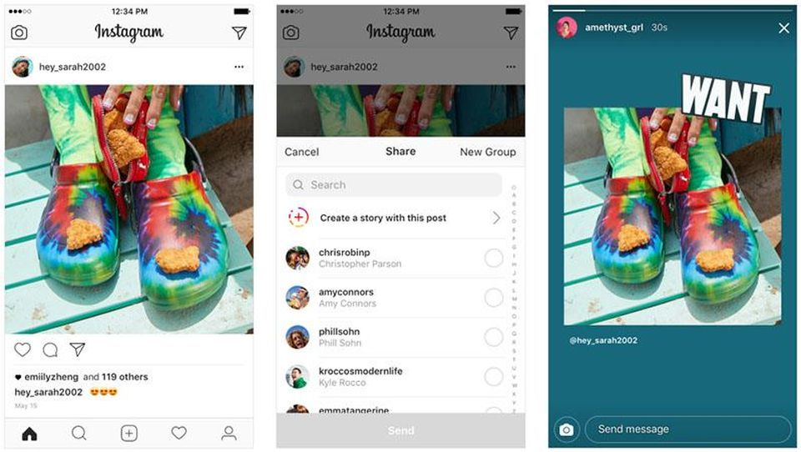

Instagram is a social media platform that is both a mobile app and has a website. You can sign in with either your username or email and password. On the platform you can customize your profile. See your followers , see who's following and view your posts.When the application is first clicked you will see your live feed which is posted on by who you are following. You can interact with these posts by liking, commenting , saving or sending the posts to friends. You can even report posts that may not be appropriate. Furthermore in the top right corner there is an icon with an instant messaging service which you can message friends, create group chats with multiple people etc.You can place posts on your story which deletes 24 hours later ,people can view this story and you can see who has viewed it. On the top left hand corner you can click the camera icon which you can then use to record and take pictures.

When the next magnifying glass icon is clicked it takes you to the explore page where all posts with the hashtag explore page go can all many people to share their content and increase awareness of their posts. On top is a search bar which can be used to search for hashtags, accounts, locations etc. When the centre bottom is clicked this is where users can post on the live feed, they can pick a picture from their gallery, put filters on their post,tag people and caption their post. Furthermore when the heart icon is clicked you see the activities page which is where you can see all the activities you have doen, e.g. what posts you’ve liked etc. finally the last icon is for your profile which can be private or public and can easily access other accounts without having to use a password. In addition to this you can go to settings to tailor them to your liking.

**Purpose:**

When instagram was first made the main purpose of it was to allow for sharing photos and videos easily from a mobile phone. It is a platform for visual communicators with easy to use features such as double tapping to like a photo or tagging another user to a photo/post. This enables other users to find new users through the photos they share. Similarly the explore page allows this to happen as it contains an ai which recommends photos to the specific user.

**Instant Messaging:**

Pros:

Organised user interface

Can increase awareness of content easily through use of explore page

Ability to make business page

Strict privacy

Overwhelming number of advertisements

Can easily switch through multiple accounts

Cons:

Limited to only photo and video sharing

Can be confusing with all the different features

From instagram i would like to replicate the live feed and the ability to like ,comment, send posts to friends also have the instant messaging services and the profile page.

Twitter

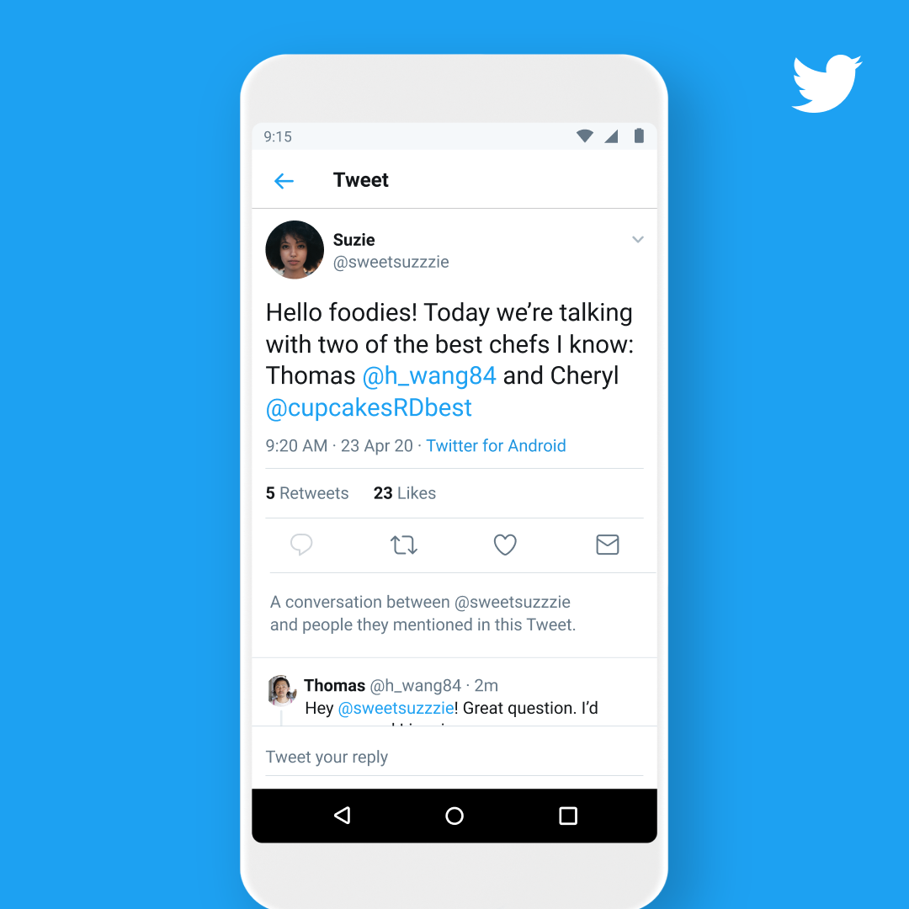

Twitter is another very popular social media platform which users post tweets, which can be anything from paragraphs to pictures to videos. Twitter has a feed which only comes up with the people you follow, it comes up with their tweets, tweets they have liked or tweets they have retweeted. Similarly they have a trending page which comes up with the most popular topics at the moment. Furthermore they have instant messaging service. You have your own profile which can have a profile picture, bio and pinned tweets which will come up at the top of your feed.

**Purpose:**

The purpose of Twitter is microblogging , it is mainly used for typing paragraphs rather than photo sharing. It is currently used for sending SMS-like messages to friends or the general public. When it first came out the limit was 140 characters. Meaning it was used for short messages rather than long paragraphs. It is a simple text based social media which has now morphed into one of the biggest social media in the world.

Pros:

Word count limit for written tweets which is 140 characters

Simplistic user interface

Cons:

No explore page

With twitter i would like to try to imitate their feed so that you can post paragraphs rather than having to post just pictures and videos.

Snapchat

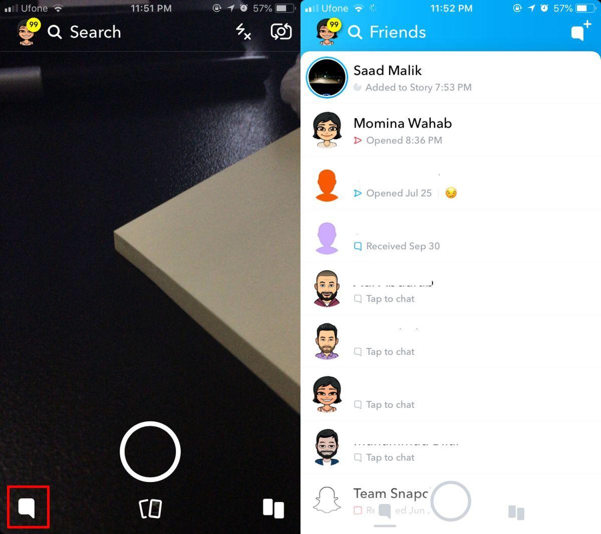

Snapchat is another popular social media app that cannot be used on a website like instagram can. It relies on snaps and stories. When the app is first started up it loads the camera which you can use to record and take pictures. You can then send these posts to either your story or your friends. On snapchat posts are never permanent. For example, if a snap is placed on your story it will only last 24 hours before being deleted and if they are sent to a friend they can only be viewed twice before being deleted. If you click on the speech bubble icon or swipe left you have access to the instant messaging service, message delete straight after use unless settings are changed. You can see when someone has viewed your message or screenshotted etc.. When you swipe less you get to a page which imitates a feed. It has your friends' posts which can be viewed but gets deleted 24 hours later. You can see posts of people you have on subscription. Below is a kind of explore page however it can only be posted on by companies and influencers so it is harder to increase awareness of your own content. If you swipe upwards you can see your saved snaps and camera roll. If you swipe downwards you have entered snap maps where you can see where other people are. You can remove yourself from this by clicking on ghost mode so people can not see where you are. Furthermore when you click on the top right icon you have a profile screen, where you can see your profile picture which is a bitmoji, see your best friends list, create a private story,which is a story where only people you have added can see and go to settings.

**Purpose:**

Purpose of Snapchat is to have video and photos which deletes after a certain period of time. It’s main purpose is to not allow the users social media history to remain. Secondly it allowed for a new type of photo and video sharing through the use of filters. Filters allow for visual effects to be put onto photos and videos.

**Instant Messaging:**

Pros:

Very secure can see what people are doing

Nice user interface

Cons:

Deletes posts every 24 hours

Deletes chats after viewing

Can switch between 2 accounts easily

Explore page can only be accessed by companies and influencers

From this app i like the feature where you can see if someone has viewed your message and has screen shotted your message hence i would like to imitate this feature.

Facebook

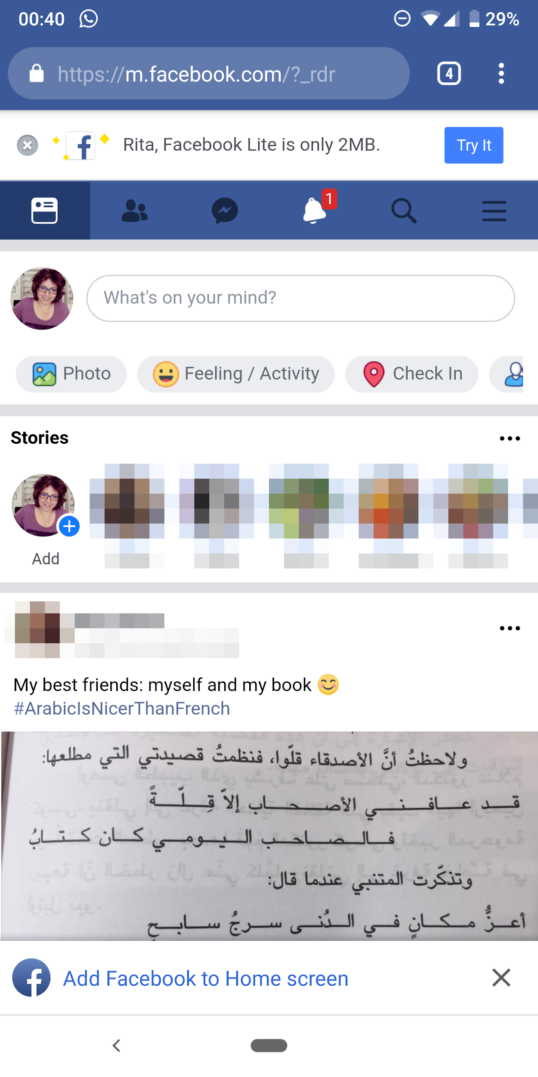

Facebook is a social media that makes it easy to connect with family and friends. On facebook you have your profile which can be personalised. You can choose a profile picture and a cover photo. You can like, follow pages, and add friends. Your timeline is a digital log of your Facebook activity in reverse-chronological order. Your status updates, uploaded photos and videos, and the photos you’re tagged in will appear on your timeline. You can live broadcast using facebook live very easily. In the direct messaging service you can send messages to friends,call, video call etc similarly you can make group chats etc. Your news feed is all the posts from your friends and accounts you follow, also posts that the facebook algorithm thinks you may be interested in. you can customise this newsfeed and prioritise whose posts you see first. Finally you can use your facebook account to connect to games which can be used as a leaderboard against friends.

**Purpose:**

Facebook's main purpose was to connect users together. It was originally created just for Harvard students however has expanded since then. It is versatile in the sense that it allows for photo sharing ,videos sharing ,business and even allows you to log into other sites. However it’s main purpose is to connect users together.

Pros:

Lots of customisation features

Can connect to games

Cons:

Lack of Privacy

Targeted advertisements

Facebook takes your personal information

Whatsapp

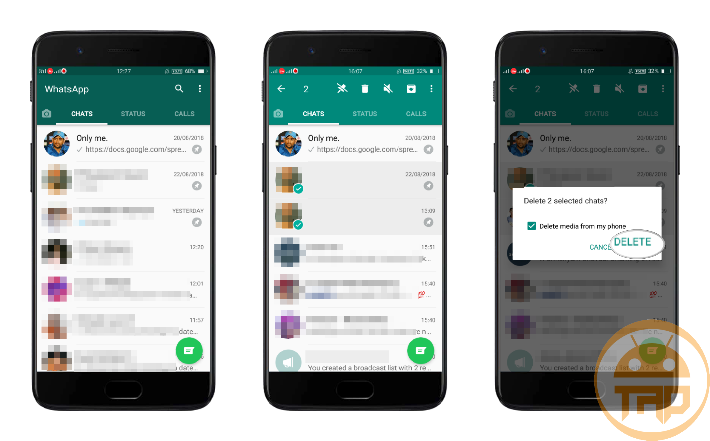

Whatsapp is a cross platform messaging app where you can send messages, voice notes, images and a range of other contents. It does not have a live feed like many of the other social medias however it has a story-like function called status which you can post on and delete 24 hours later. You can also call people. In the main screen you can create group chats and also create broadcasts which are sending multiple people a message without having to do it individually or by making a group chat.

**Purpose:**

WhatsApp purpose is to directly message people this may be through text, voice message, video or calls. It allows you to message an individual or a group of people.it’s main purpose is exclusivity as it does share your texts through other people the text stays between the user and the individual or group they have texted it too.

Pros:

Secure

Can send to a number of people without making a group chat

Cons:

No live feed

Houseparty

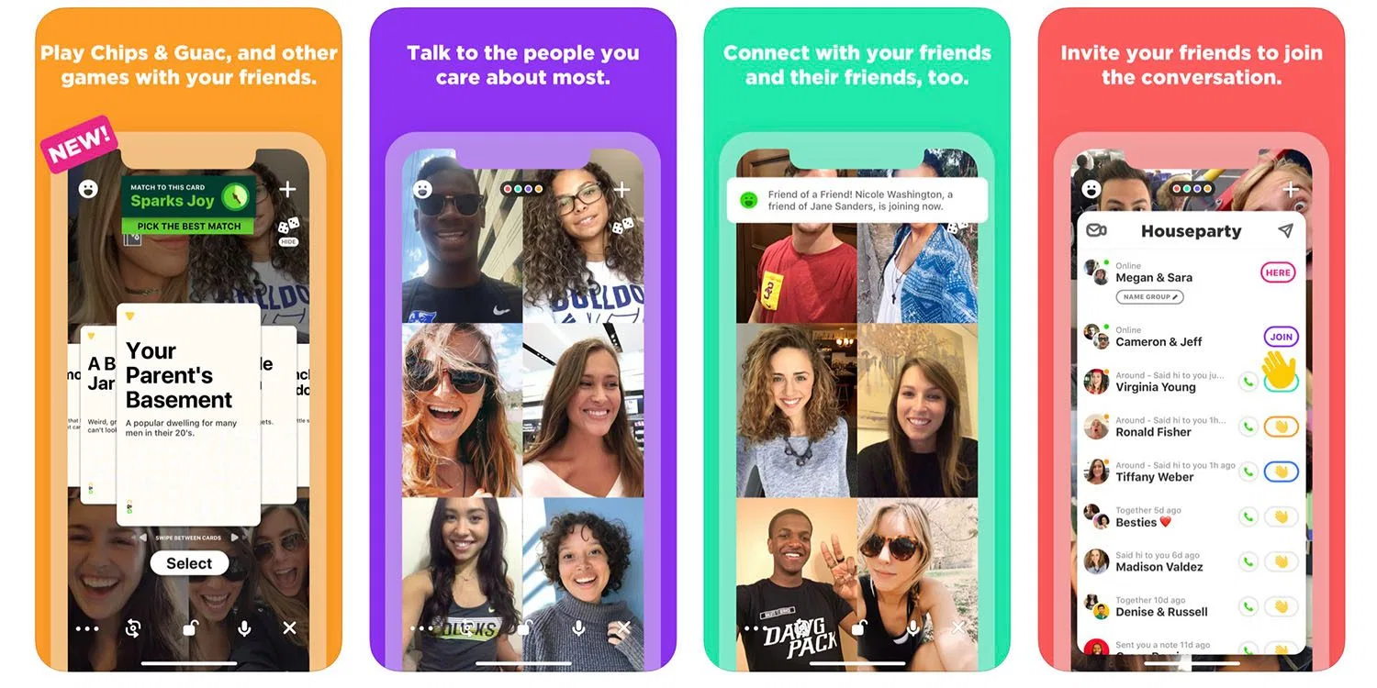

Houseparty is a social networking platform which enables group video calls through mobile app or desktop hence it doesn't have posts or likes etc.When friends are available to talk it will send a notification to everyone on their friends list. When you first click on the app your camera comes on, anyone can join you, this can be stopped by pressing the lock icon which puts the call in a private like call. On calls you can play games, invite people to chat etc. When you swipe upwards you can see all your friends and what calls they are in. When the arrow icon in the top right corner is pressed it takes you to the instant messaging service.

**Purpose:**

Houseparty is a video calling social media that splits the interface up to 8 different sections and allows users to talk and play games etc. It is a face to face social media that doesn’t involve any photo or video sharing.

Pros:

Can play games

Alerts when someone is available to talk to

Can be linked to snapchat

Cons:

Can be confusing to use at times

Cannot post videos or pictures

Youtube

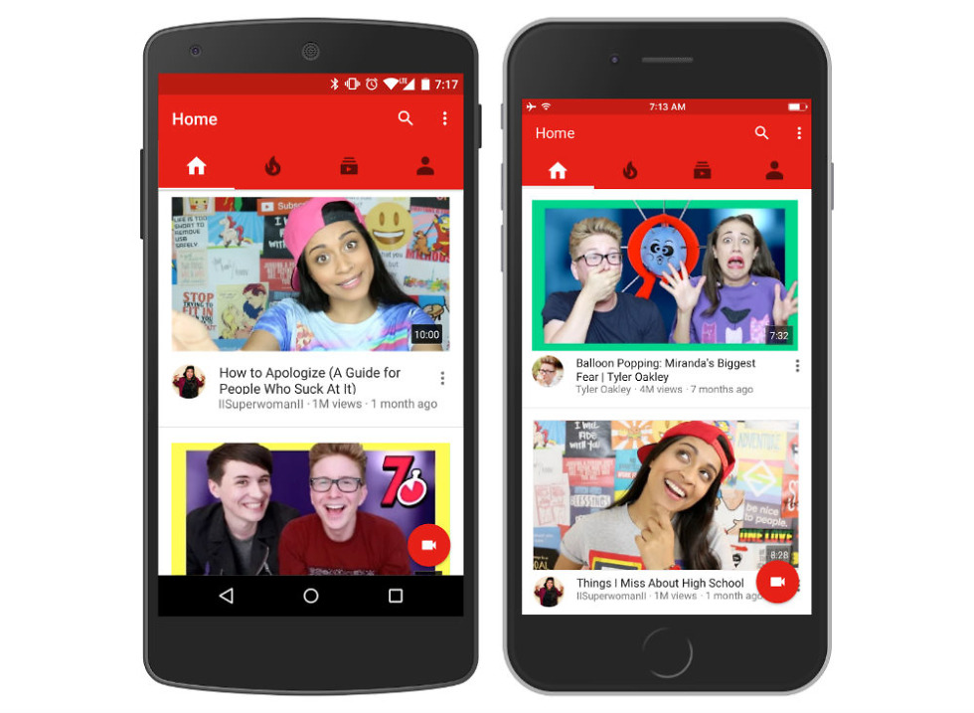

Youtube is also a video sharing social media platform for both mobile and desktop. People usually post videos on youtube but pictures can also be uploaded. The videos can be liked, disliked,commented on and saved to a playlist. Furthermore you can subscribe to youtubers and click a bell icon to be notified every time a youtuber uploads. On the first screen when the app is loaded you will see the feed, this is where you will see posts of who you watch most and of videos that you might be interested in. next to it you will see the trending page where the most video videos will be. Next to this you will see your subscriptions where all the videos of who you have subscribed to will be located. Then finally next to this is the profile where you will be able to see your playlist change settings etc.

**Purpose:**

YouTube is a video sharing platform that mainly has longer videos than short ones. These videos can be on the topic of anything the user wants. It is spread using an algorithm to target the people who watch videos most like it. This increases the awareness of the video as a result YouTube’s main purpose is to share videos.

Pros:

Can upload long videos

Trending page

Cons:

No instant messaging service

Lots of ads

Finding a Purpose

Questionnaire

I wrote a questionnaire to gain a better understanding of the features that are wanted on the social media network.

Majority of the people using the network will be around the teenage years however many people could be over the age of 20 and over. Hence I will make the assumption that they are well versed in using social media.

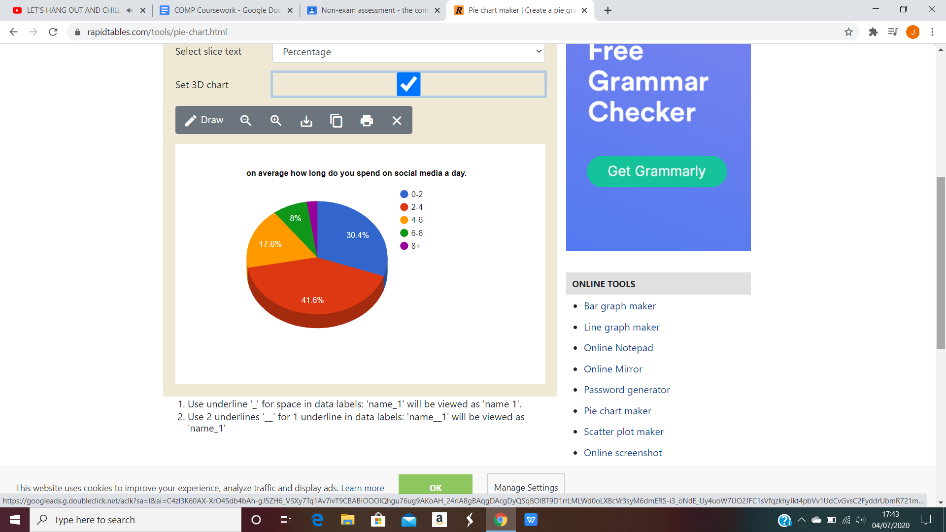

The time spent on social media is quite varied. From 0 to 2 hours it has taken around 30% (so a little experience with using social media). To 4-6 hours which takes up 18% of the chart (which is experienced with social media). The extreme seems to be over 6 hours a day on social media. Hence I am going to assume that the majority of the people know how to use social media and hence i will not include a tutorial on how to use it. Rather I am just going to start the program just with the authentication screen so the user can register their account.

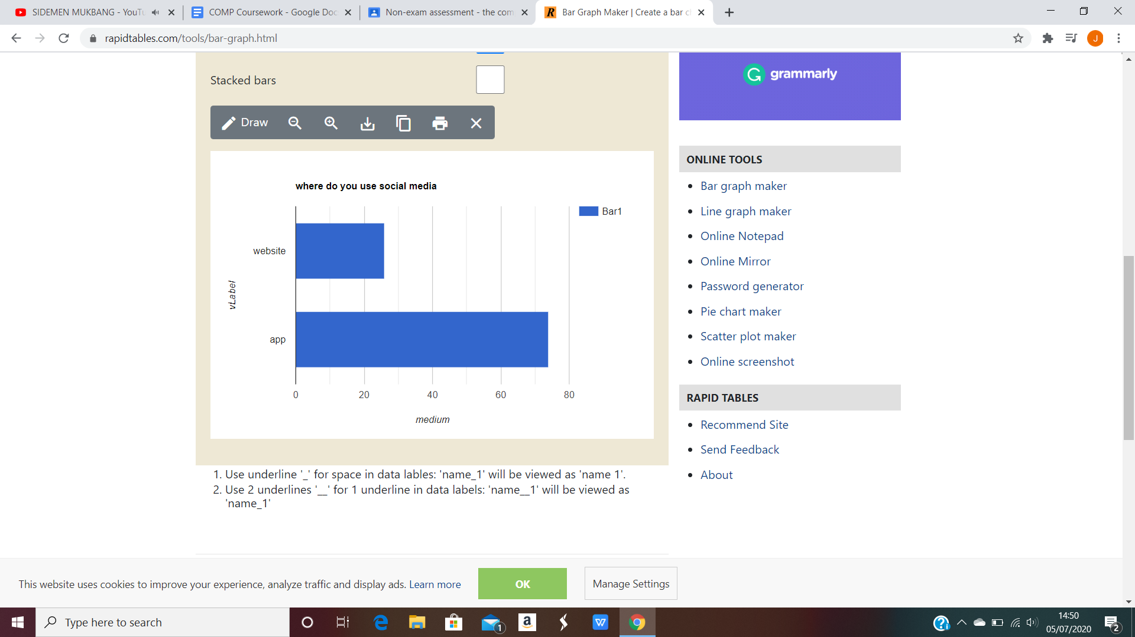

The minority of people use websites that don't allow mobility and hence this is less significant. Majority of people use Social media on a mobile device. This allows them to use it on their phone and tablet. This allows it to be more portable, so it can be used easily in different places. Therefore i am going to make it easily accessible for mobile use however it may not be an app. Making it a website will allow it to be used on both mobile devices and PCs, whereas app can only be used on mobile devices.

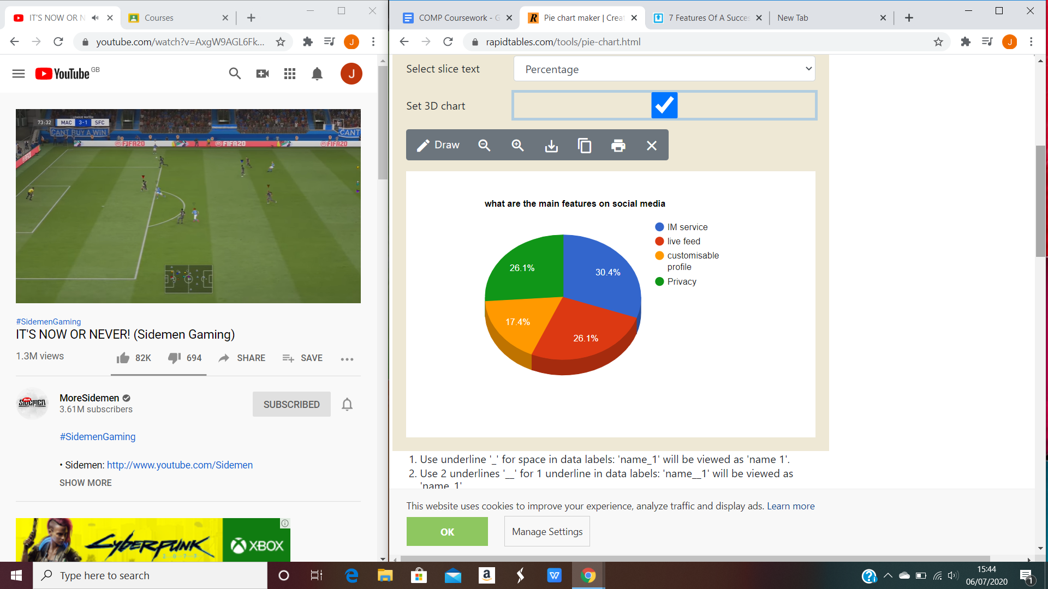

From the survey we can see the most important feature is the instant messaging service. This allows users to send a text message to another user in real time. Similarly the ability to make group chats where multiple users can have a conversation in real time can be very useful. This makes it easier to communicate with others on the app. Furthermore instant messaging has also affected big companies on their websites, many companies for example, carphone warehouse, have included an instant messaging service to communicate with their customer service staff this makes for a simple way to communicate and to answer questions easily rather than calling or sending an email.

The next most important is privacy and live feed. Next i am going to talk about the live feed as i believe it is what makes most of the social media. Social media is a platform where you can share content whether it is what is important to the user or something that is random. The live feed encapsulates the idea of a network where everything is connected hence many people can see the post. It allows the app to generate a constant flow of relevant content and for users to interact with other users, hence easy connectivity between individuals.

Next is something that is easily as important as the other features which is privacy. If there is not enough privacy and security personal sensitive information can be accessed and potentially stolen. Hence i will have an authentication system which consists of a username and an eight character or more password. This will allow for less security breaches to happen.

Finally there is a customisable profile page. This allows users to express themselves using their profile. I will allow them the option to make the profiles private or public so if they don't want others to look at their profiles they can put it on private.

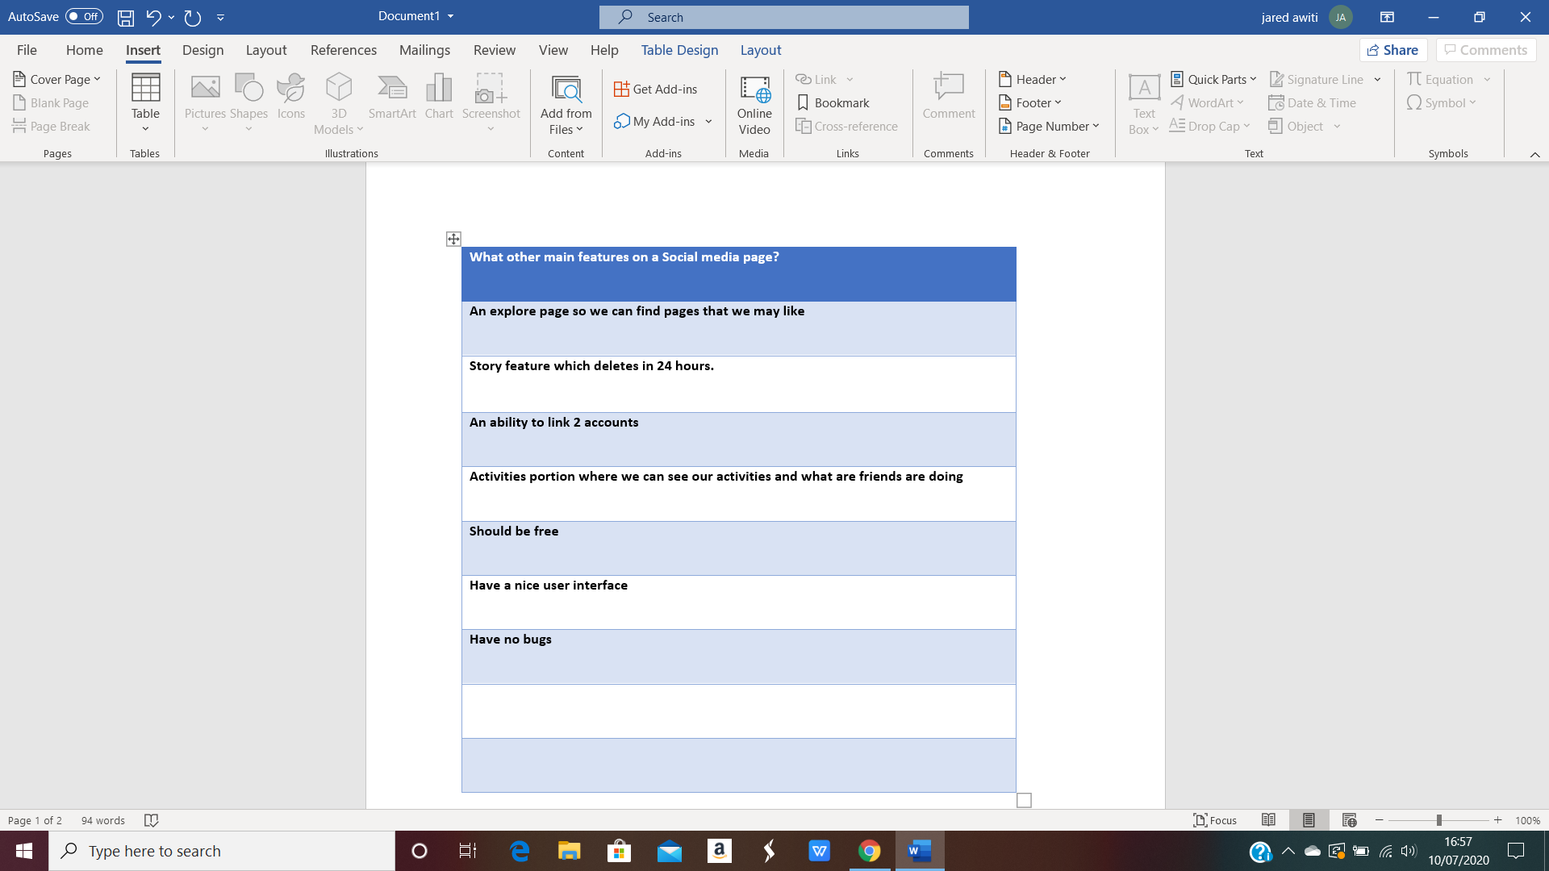

Other main features of social media :

“An explore page so we can find pages that we may like”- i will aim to have an explore page where people can find other posts.

“Story feature which deletes in 24 hours”- instead of stories i will have the main feed where you can post, if you do not want your post to be there anymore i will make an option to delete it.

“An ability to link 2 accounts” - i will not have an ability to link 2 accounts however you can make multiple accounts.

“Activities portion where we can see our activities and what friends are doing”- i will have a section where you can see the activities of your followers.

“Should be free”- it will be free.

“Have a nice user interface”- the user interface will be professionally looking.

“Should be bug free”- i will do extensive testing to make sure there are little to no bugs on the network.

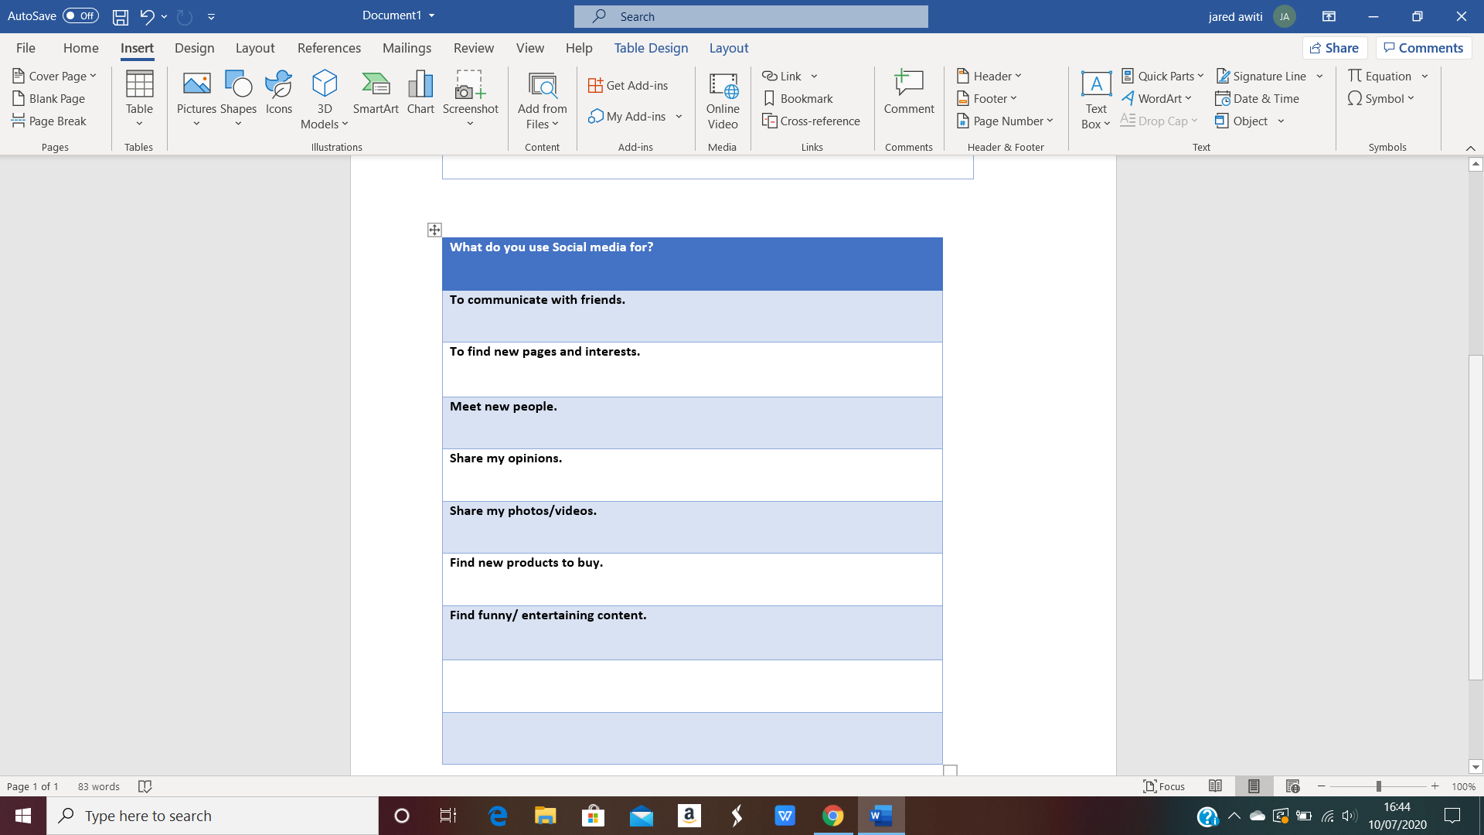

Through this I have confirmed that social media is mainly about interaction. People use social media for a variety of reasons however they all tie to the genre of interaction. Whether it is talking to friends , finding and liking posts or just sharing your posts or opinions. Social media is mainly used to interact with others while not being physically next to someone.

Prototyping

Over the summer holiday I created a prototype of the social media platform I was going to be making. I initially thought i would make a social media using django and html however as i did more research i found out that flask was a better alternative for websites making. This is because it is a light-weight extensible framework, flask allows simplicity and more flexibility for the developer.

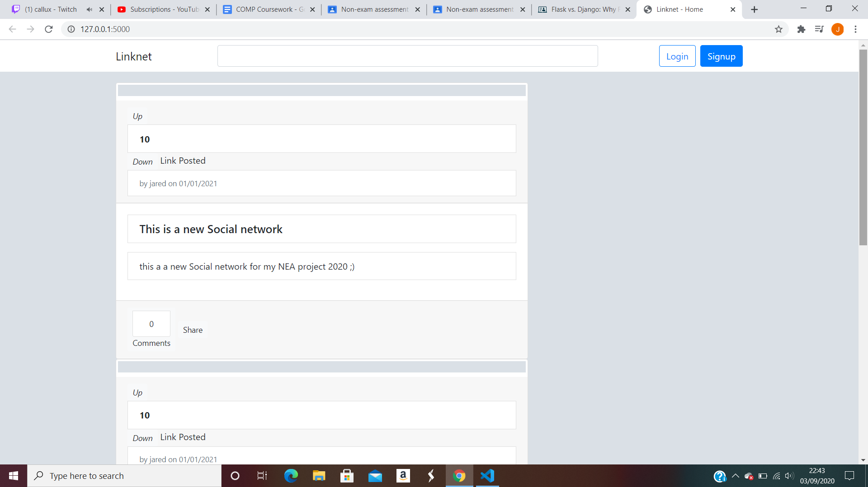

This is prototyping the post forms which has a title,number of comments,body of the post,user created by,date created and the like and dislike button which are currently up and down.

**Screenshot of prototype**

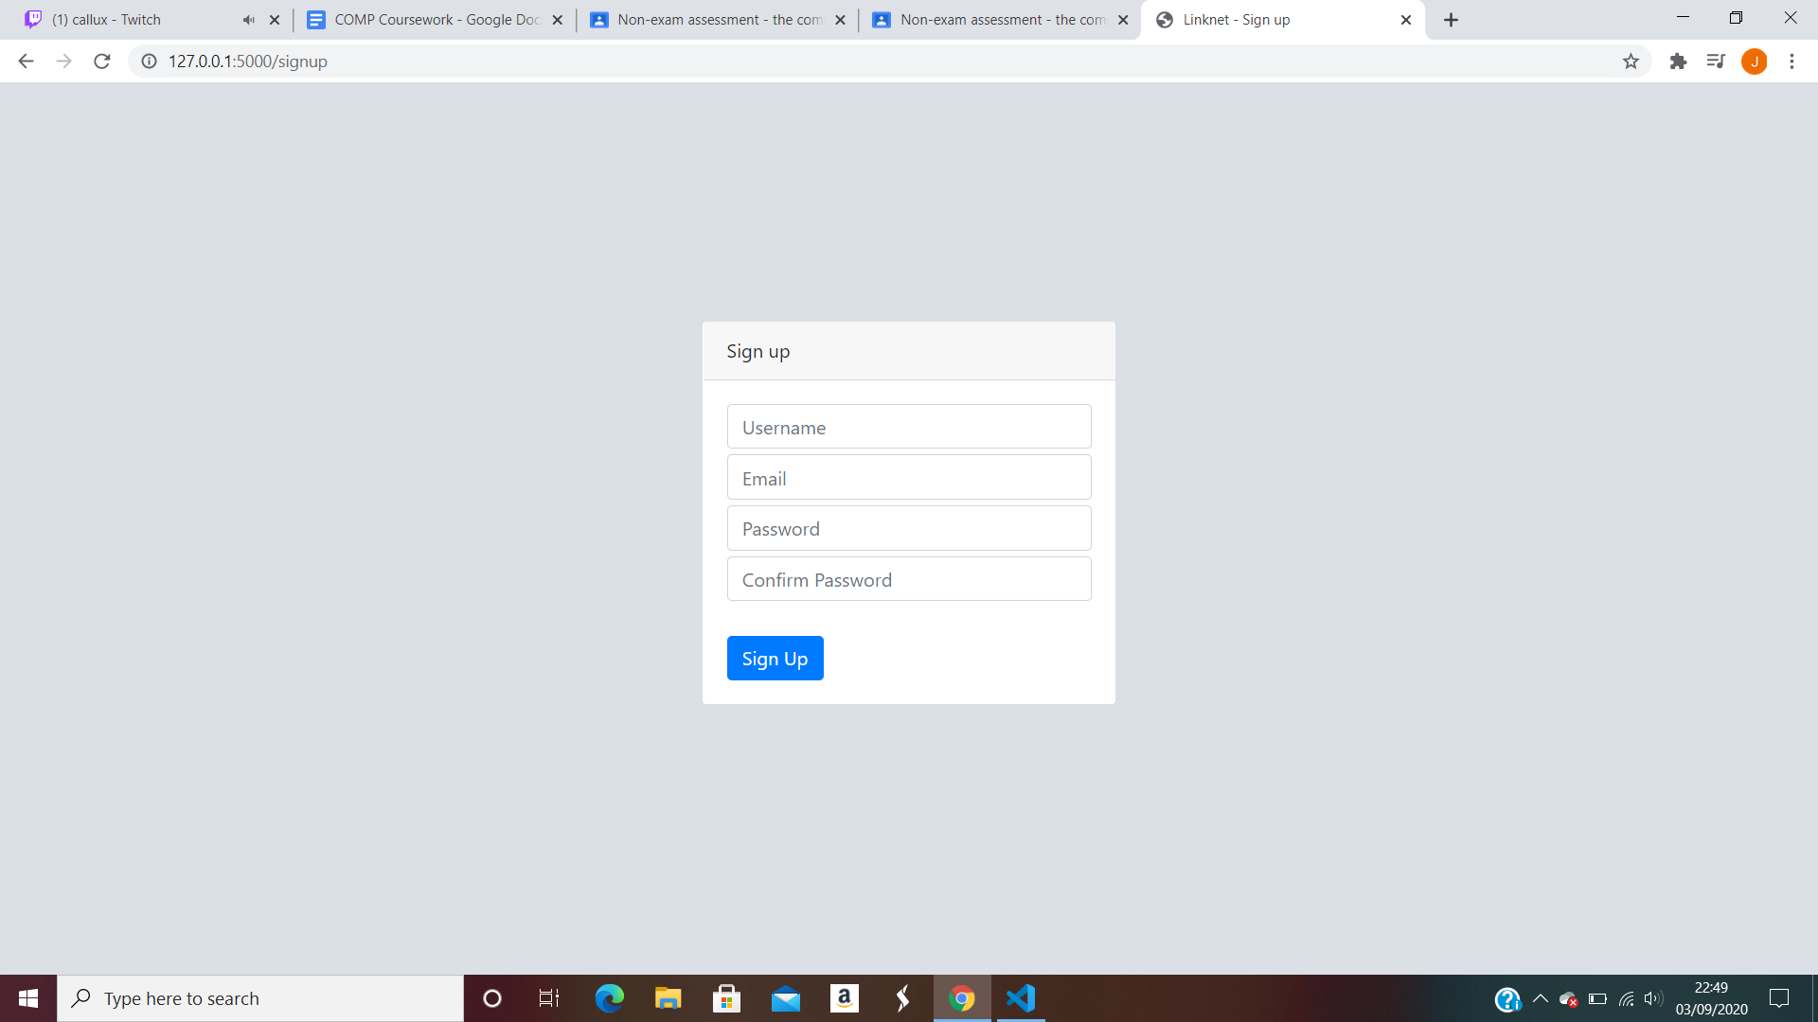

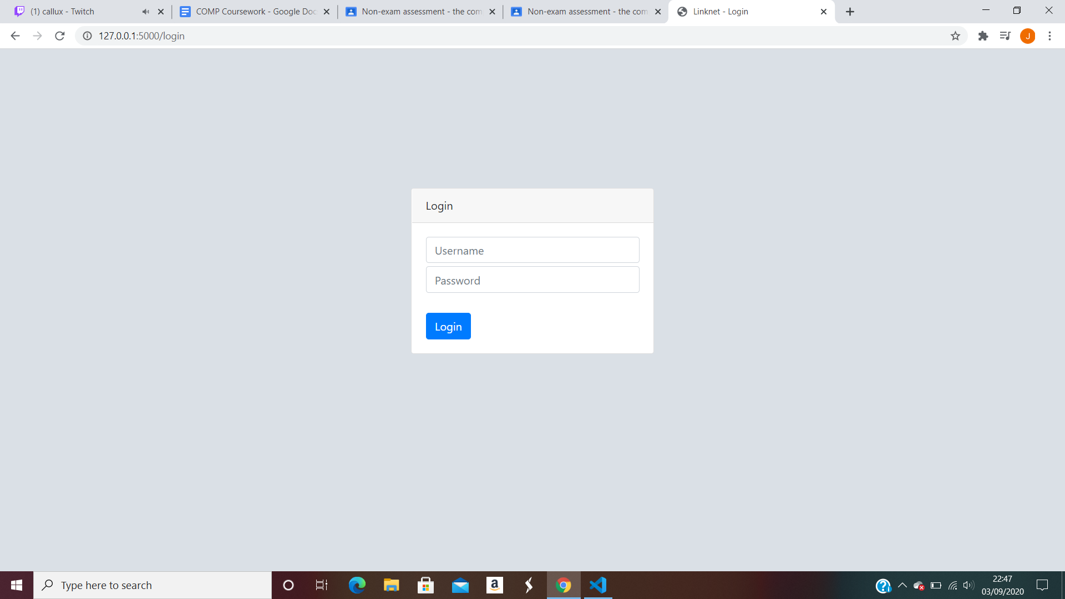

At the beginning of the project I had very little knowledge of html and flask however i slowly started to learn more about html and flask and was slowly adjusting to the syntax of html.

I have been able to prototype the login page, signup page, home page, and some posts with the comment button and like, dislike and share buttons.

**1.3 Objectives**

MOSCOW analysis

General objectives

1. User able to register account successfully
2. User able to login into a registered account successfully
3. User able to post onto the main page successfully
4. User able to comment on posts
5. User able to like or dislike a post
6. User being able to directly message another user

Specific Objective

User able to register account successfully

* Using flask
* Put into a Sql database
* Password hashed and random salt
* Password at least 8 characters and need a number and capital letter

User able to login into a registered account successfully

* Compare inputted password and username to database
* Have a forgotten password option in login place

User able to post onto the main page

* Have the details of each post
* Be able to add post to home page
* Be able to remove post from home page
* Posts saved in sql file with other information

User able to comment on posts

* Have a counter for amount of comments
* Be able to like and dislike comments

User able to like or dislike a post

* Add and removes likes and dislikes
* Number of likes and dislikes

User being able to directly message another user

* Be able to send a message to another user successfully
* Be able to delete messages once sent successfully
* Can successfully message a group chat
* Successfully use client server communication

**1.5 - Limitations**

There will be many limitations to my project. This may include:

**Documented Design**

**2.1 - High level overview**

These flow charts will show how the program will run from the homescreen. Each different button will go to a different screen.

REGISTER FLOWCHART

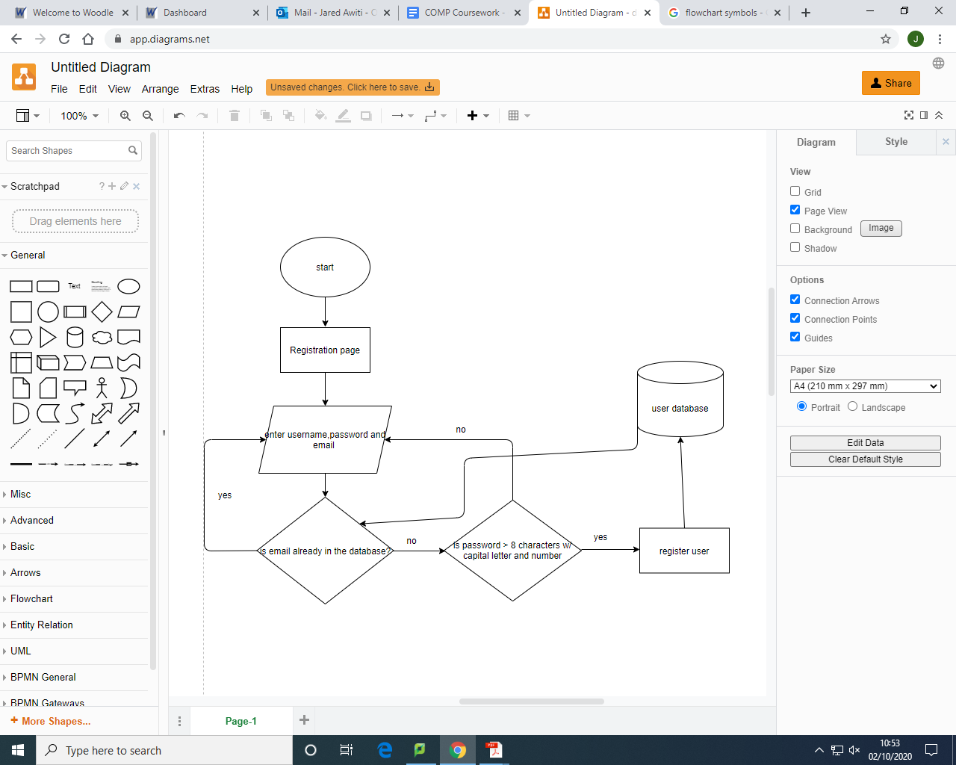

LOGIN FLOWCHART

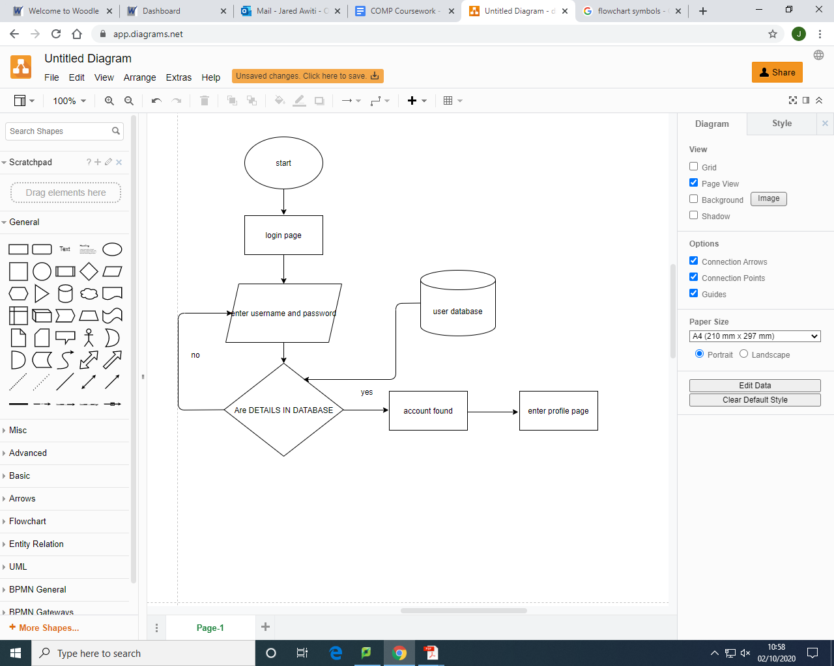

Account Actions Flowchart

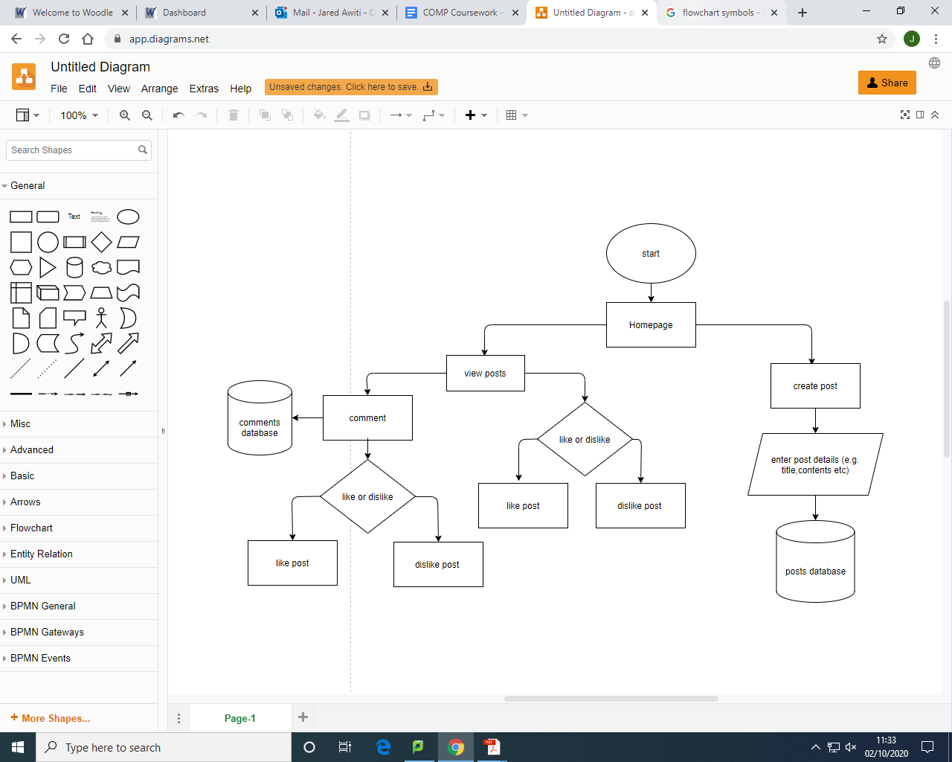

**2.2- Front End User interface**

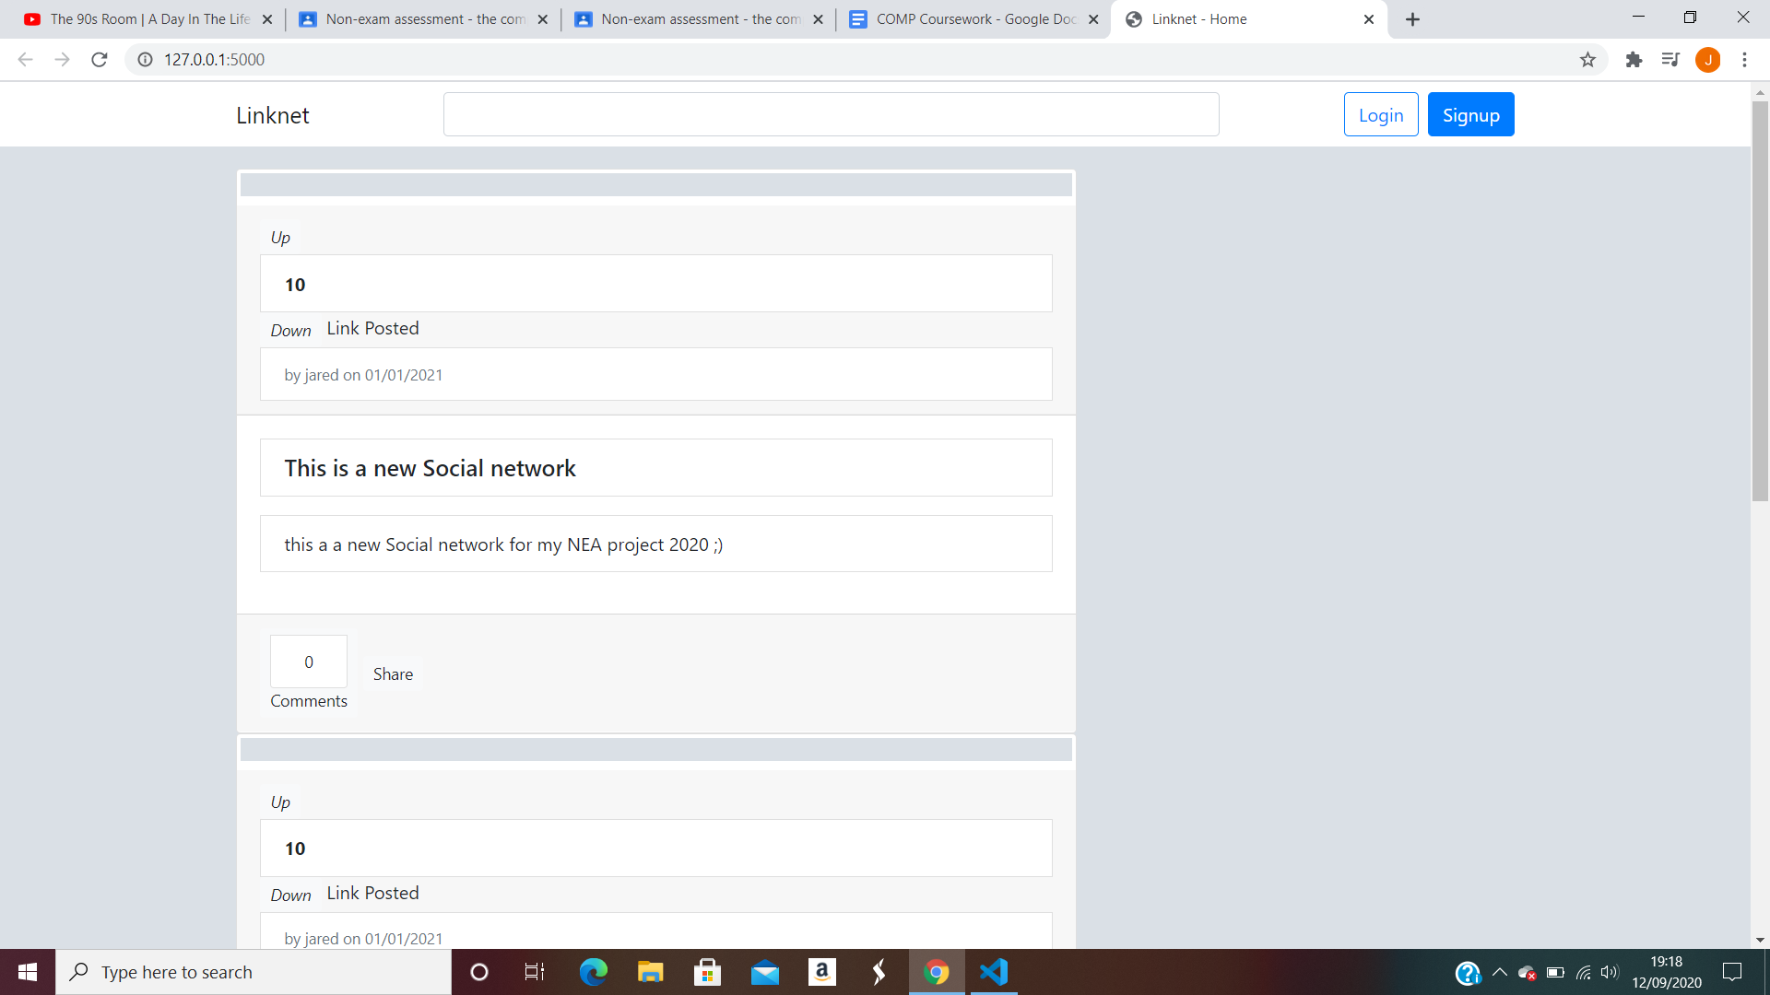

This is the initial Homepage that will show when the page is first logged onto. It will be connected to a database so that when users update their feeds it will allow the posts to go onto the main page. This will be the layout of the page which will be able to be liked or disliked or have comments onto it by users. On this page you can also share the post to other users. There is a search table to be able to search for users.

Similarly clicking the linknet logo would have caused the page to refresh.

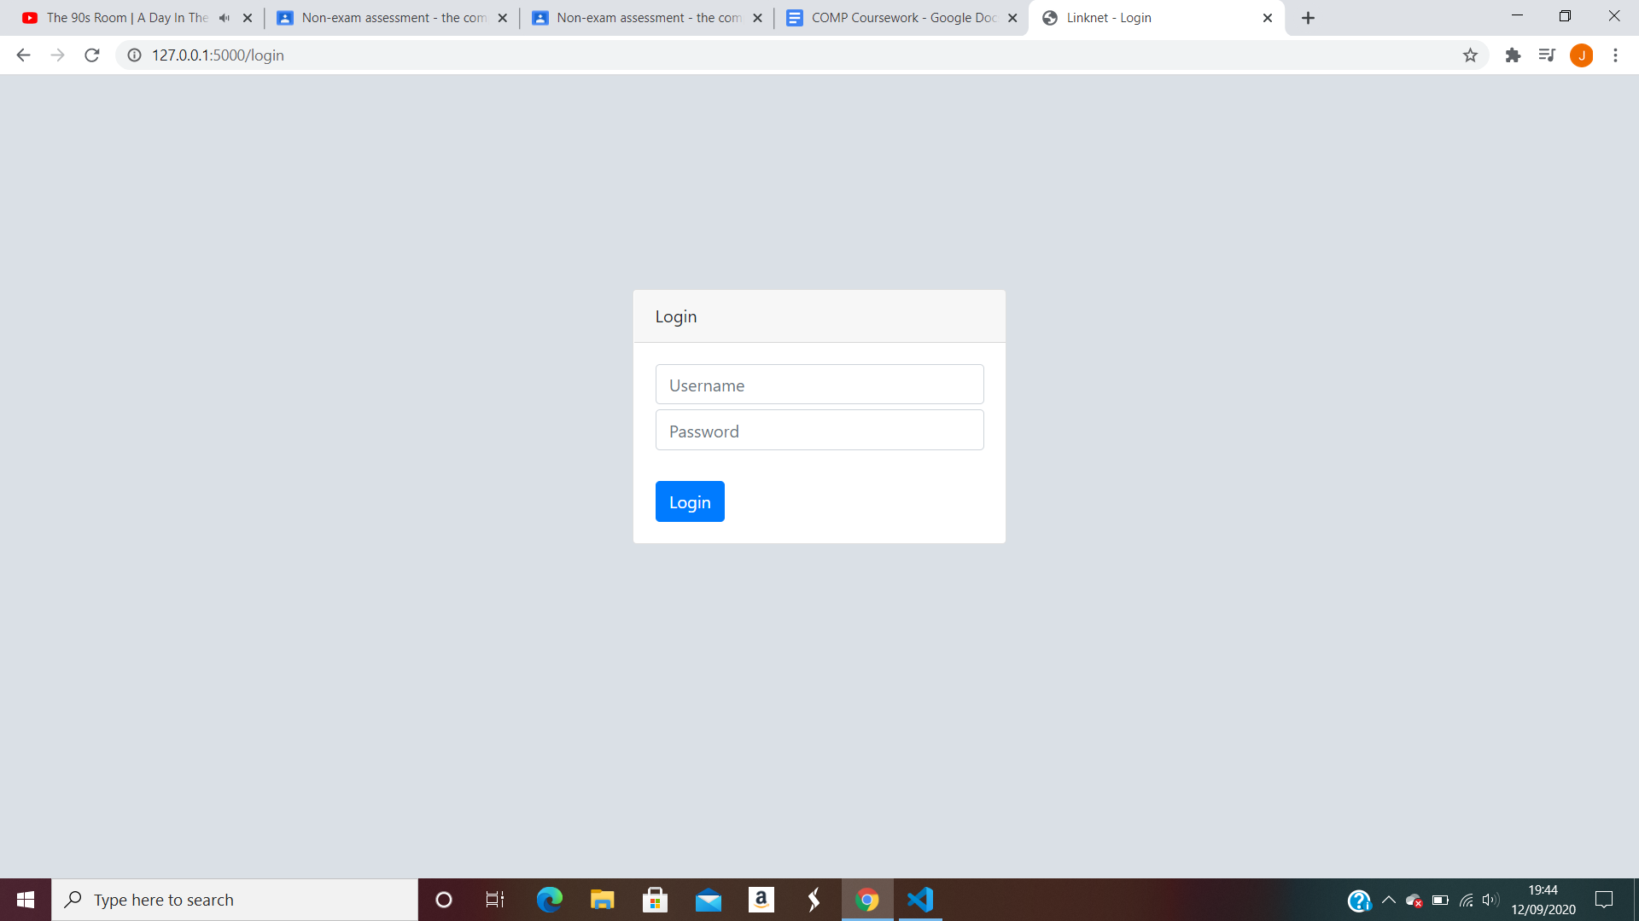

This is the login page the username and password needs to be entered. If the wrong combination of username and password are entered it will reload the page. In a later implementation a message will be displayed saying that the username or password are incorrect. Further I will try add a forget password option that will send a link to the email provided to reset the password. However for now it is just username and password. Furthermore once the details are entered it will be compared to the details in the sql database.

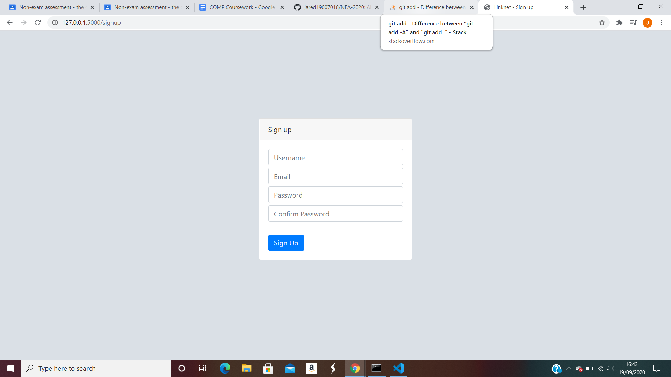

This is the sign up page it requires the Username, Email, Password and an extra column to Confirm Password. This is to make sure that the username has not mistakenly entered a different password. Once all the details have been entered it will be stored in an sql database. The username and password can then be used to to login to the site.

**2.3 - IOPS Chart**

|  |  |
| --- | --- |
| **Input**   1. Username 2. Email 3. Password 4. Posts content 5. Like Post 6. Comment | **Process**   1. Login verification and validation 2. Login database update when signing up |
| **Storage**   1. Login database 2. Posts database 3. Comments database 4. User account information | **Output**   1. Post 2. User state prompt(e.g. Incorrect password) 3. Comments |

**2.4 Data Dictionary**

User Table:

|  |  |  |  |  |  |
| --- | --- | --- | --- | --- | --- |
| **Fieldname** | **Field type** | **Field size** | **Purpose** | **Example** | **Validation** |
| userID | INT |  | Unique identifier for each user: primary key :auto incremented | 3 | Is numeric? |
| username | VARCHAR | 20 | Store each users username | jared | Not empty, under 20 characters |
| hashed_password | CHAR |  | Store each users password | 3hgge567 | At least 8 characters unhashed with at least 1 capital letter and number |
| salt | CHAR |  | Salt the hashed passwords | 3hg%ge5%67 | n/a |
| email | STRING |  | Connect the email of the user to the account | tt@gmail.com | Not empty |

Posts table:

|  |  |  |  |  |  |
| --- | --- | --- | --- | --- | --- |
| **Fieldname** | **Field type** | **Field size** | **Purpose** | **Example** | **Validation** |
| postid | INT |  | Unique identifier for each post: primary key: auto increments | 11 | Is numeric? |
| title | STRING |  | The title of the post | This post is dedicated to someone | Not empty |
| body | STRING |  | The contents of the post | “Today is a good day for money” | Not empty |
| username | VARCHAR | 20 | Username of the user who posted | jared | Not empty, under 20 characters |
| date_created | DATETIME |  | The date the post was created | 23/09/2002 | In the format DD/MM/YYYY |
| num_comments | INT |  | Number of comments | 55 | Is numeric |
| up_votes | INT |  | Number of people who liked the post | 58 | Is numeric |

UserPosts:

|  |  |  |  |  |  |
| --- | --- | --- | --- | --- | --- |
| **Fieldname** | **Field type** | **Field size** | **Purpose** | **Example** | **Validation** |
| userID | INT |  | Unique identifier for a user: Foreign key | 52 | Is numeric? |
| PostID | INT |  | Unique identifier for a post: Foreign key | 5 | Is numeric? |
| Contents | STRING |  | The contents of the post | A video or a message e.g. “Hello my name is jared” | n/a |

Comments:

|  |  |  |  |  |  |
| --- | --- | --- | --- | --- | --- |
| **Fieldname** | **Field Type** | **Field size** | **Purpose** | **Example** | **Validation** |
| postid | INT |  | Unique identifier for a post: Foreign key | 9 | Is numeric |
| userid | INT |  | Unique identifier for a user: Foreign key | 13 | Is numeric |
| commentid | INT |  | Unique identifier for a comment: Primary key | 55 | Is numeric |
| comment | STRING |  | The contents of the comment displayed | “This is funny” | n/a |
| upvotes | INT |  | The number of likes on a comment | 13 | Is numeric |

**2.5 - Database design**

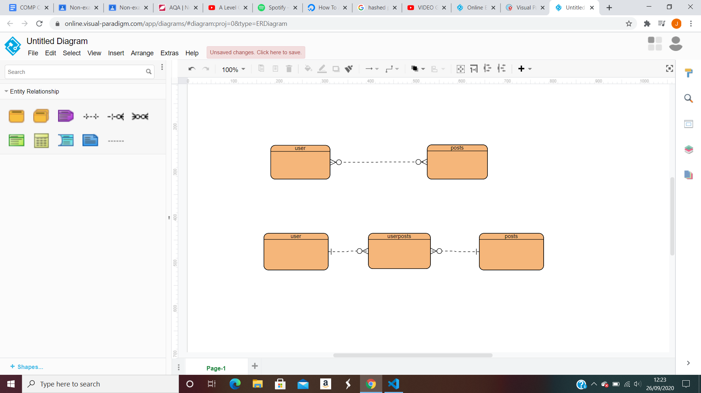The sql user table holds information about the user. This holds the username, the password,hashed password, salted password and email address.

The sql posts table holds information about the post; this includes title,contents,date created, user who created the post ,comments etc.

The ERD diagram shows the relationship between the two tables. The user table has a many to many relationships with the posts table. This means many users can have many posts.However many to many relationships tables do not have direct links as we don't know how many of one si lkinking to how mant of another. To fix this we need to introduce a linking table between the two tables.

The user post table holds information about what one user posts; this could be userID, postId and contents.this consists of a primary key which is a composite key made up of postid and userid .

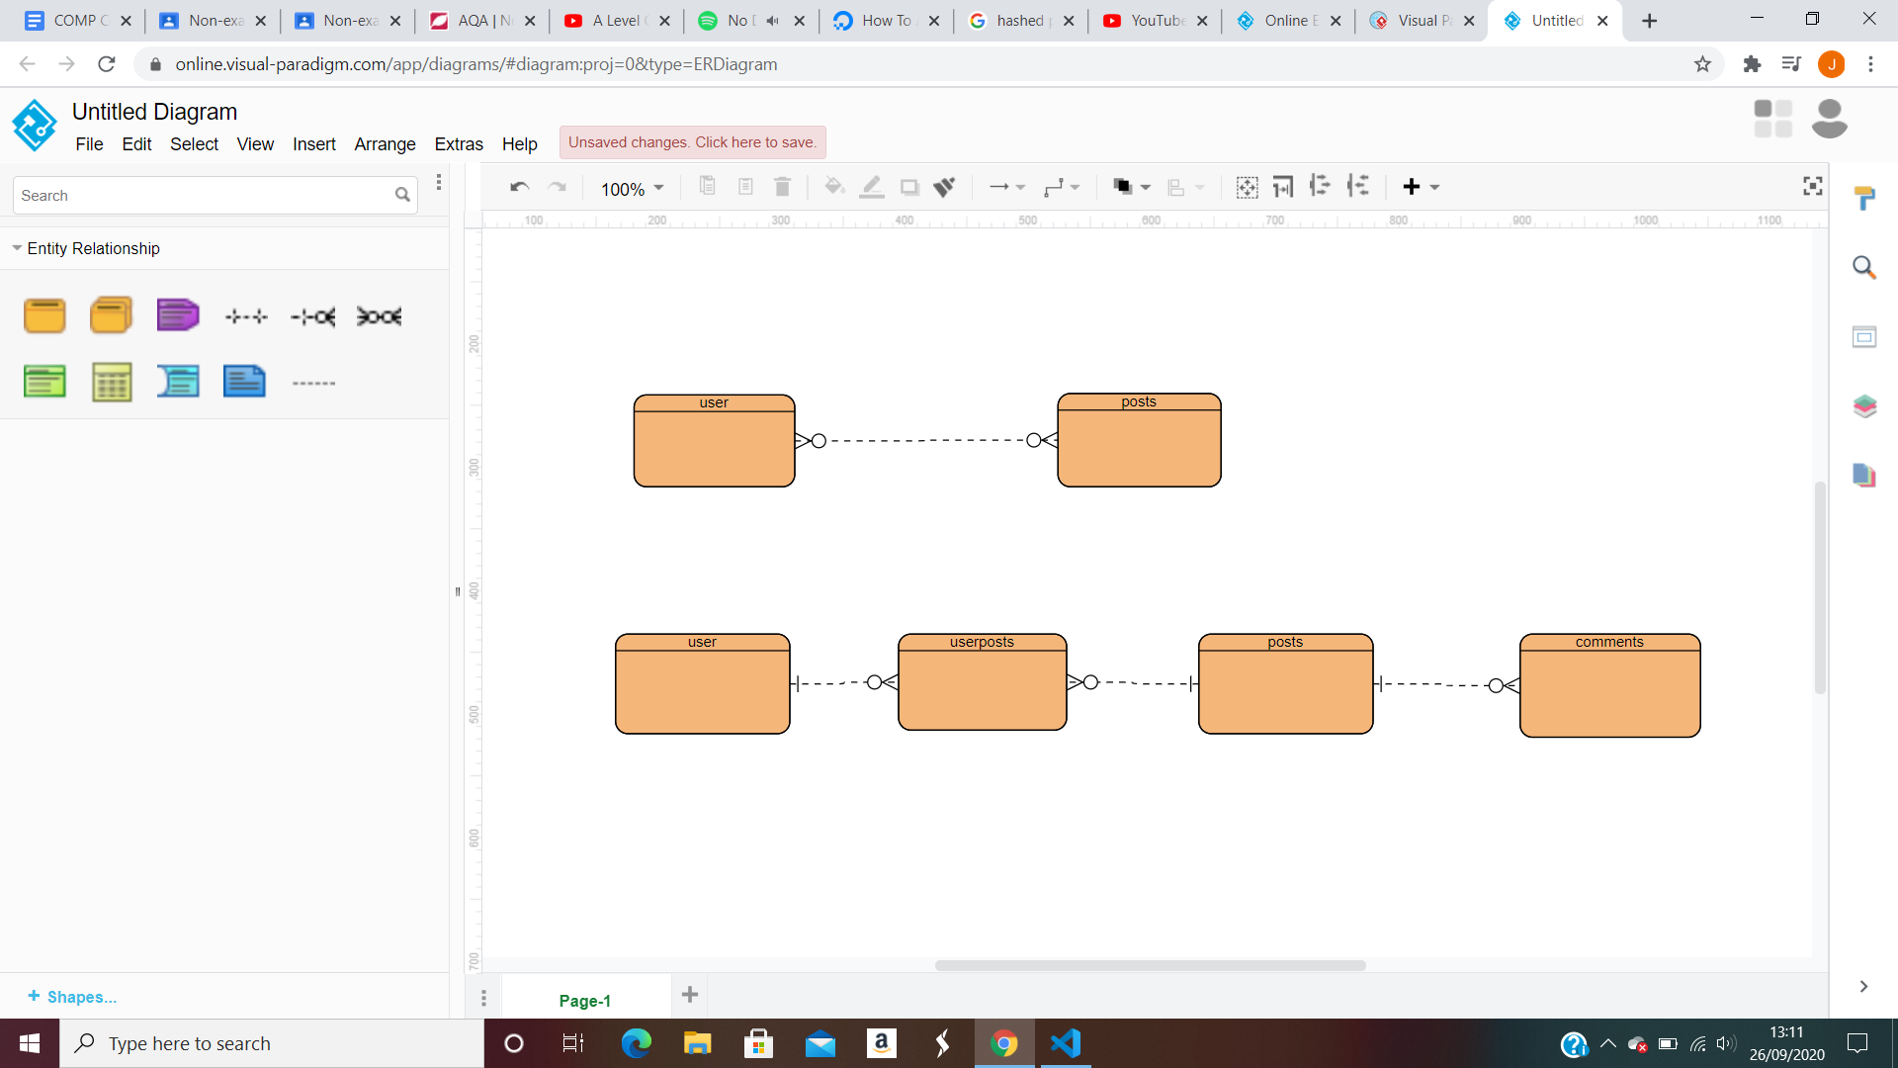

At the end we can see a final table which contains the comments on the post, this holds all the information about comments; including contents, user who created the post, and number of upvotes etc.

Normalisation

**2nd normal form/3rd normal form**

The design of the tables will either be in 2nd or 3rd normal form. This is because in 2nd normal forms the tables have no partial dependencies, this needs a composite key to occur. In my table the Userposts table has a composite key of userid and postsid. This makes it the 2nd normal form.

However it could also be in third normal form as in third normal form all entities are dependent on the key, the whole key and nothing but the key. In all of the tables the entities are dependent on a key.The user table is dependent on the userid the postid is dependent on the posts table and the comments table is dependent on the both posts and user id.

In first normal form it may be difficult because there could be repeated attributes. However we can make it the first normal form by splitting up the table.

For example

Posts(PostID,title,body,username,date_created,num_comments,up_votes)

Userposts(PostID,UserID,contents)

The tables are not in first normal form.

**2.6- Planned SQL Queries**

CREATE TABLE user

(

Userid INT NOT_NULL AUTO_INCREMENT PRIMARY KEY

Username VARCHAR(20) NOT NULL

Hashed_password VARCHAR(30) NOT NULL

Salt VARCHAR(50) NOT NULL

Email VARCHAR(40) NOT NULL

)

CREATE TABLE posts

(

Postid INT NOT_NULL AUTO_INCREMENT PRIMARY KEY

Title VARCHAR(40) NOT NULL

Body VARCHAR(40) NOT NULL

Username VARCHAR(40) NOT NULL

Date_created INT NOT NULL

Num_comments INT

Up_votes INT

)

CREATE TABLE user posts

(

Postid INT NOT_NULL AUTO_INCREMENT FOREIGN KEY

Userid INT NOT_NULL AUTO_INCREMENT FOREIGN KEY

Content VARCHAR(100) NOT NULL

)

CREATE TABLE comments

(

Postid INT NOT_NULL AUTO_INCREMENT FOREIGN KEY

Userid INT NOT_NULL AUTO_INCREMENT FOREIGN KEY

Commentid INT NOT_NULL AUTO_INCREMENT PRIMARY KEY

Comment VARCHAR(40) NOT NULL

Upvotes INT

)

Inserting new user into database:

INSERT INTO USER (userid,username,hashed_password,salt,email)

VALUES(NULL, jared,23ddd566,23$dd$d5$66$,[jared@gmail.com](mailto:jared@gmail.com))

Null value used for id because it auto increments

Adding a new post onto the website:

INSERT INTO POSTS(postid,title,body,username,date_created)

VALUES(NULL,hello,hello world,jared,23/09/2002)

Null value used for id because it auto increments

Commenting on a new post:

INSERT INTO COMMENTS(commentid,contents)

VALUES(NULL, good post)

Null value used for id because it auto increments

**2.7 main algorithms**

Sign up algorithm

This sign up algorithm will be used to enter new users details into the sql database. It uses a hashing encryption in order to make sure the data entered is safe. This is because it uses a hashing function; this is a one way process which scrambles plaintext to produce a unique message, this is irreversible. After this to ensure more security the passwords are also salted; which is when a unique character or symbol is added to the password every certain amount of characters. If the email or username is already in the database an error will occur and

Login algorithm

When a login is entered the database is queried. If the username is not found an error will occur and the user will be taken back to the login page. However if it is found and both the username and password is correct the program will open up the profile page.

Profile algorithm

This holds the profile of the user.

**2.8 - Instant messaging server**

Peer-to-peer Vs Client-server

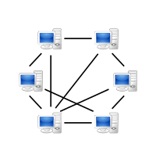

Peer to peer model is when all terminals have equal status.Each computer acts as both a client and server. There is no central node.

ADV

* No specialist OS required
* Flexible with ability to add new machines and share resources
* Can decide what resources will be shared by each machine

DISADV

* Backups need to be done on each machine to prevent data loss
* Sharing connection resources could slow the machine down for the person using actual machine
* Can reach a point to where it is impossible to manage user permissions and accounts will need to be set on each machine

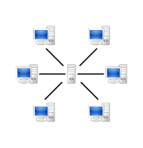

Client server model is when the client requests services from the server .it seperates functions and allows efficient allocation of resources. However the server becomes a point of failure if it goes down the whole network goes down.

ADV

* All files stored in central location and be accessed from any machine
* Backups and network security controlled centrally
* Users can access shared data which is centrally controlled users can login to any machine

DISADV

* Any part of network fails a lot of disruption can occur
* Specialist network OS needed

Client Server model is better to use for the instant messaging service because it is more secure than peer to peer because with peer to peer security is handled by individual computers whereas with client server it is handled by the main server. The device connects with their server. It could then use a TCP protocol to communicate the messages to the server. The server then dispatches them to your friends device.

**2.9- Techniques**

Flask sessions

I will be using flask sessions in my program. With sessions we will be able to pass around variables more easily on the backend on the websites. This will be much more time saving then continuously passing variables through parameters which will most likely cause many errors and complicate the code.

Sessions are more favourable because they are temporary, they are stored on the web server and they allow for quick access of information between different pages of the website. Sessions are active when the user is using the website then when they come off the data is erased. Afterwards when the user uses the website again the session data is reloaded.

A session requires a secret key. This is because all the session data stored is encrypted. To encrypt when storing data or decrypt when GETing the data this requires the secret key. The more complicated the secret key is, the more secure the session data will be.

By using permanent sessions in flask we can store data for much longer. With permanent sessions we can define how long we want the data in sessions to be stored for.

Session has allowed me to pass the username on the profile page without me passing unnecessary data through classes and objects.

Sql vs sqlalchemy

SQLalchemy is a python SQL Object relations mapper that gives the power and flexibility of SQL

I will be using SQLalchemy instead of SQL. This is because :

Robustness: i do not need to know the syntax errors i might make if i wanted to use different database sources, for example MySQL or MongoDB. I just need to use the same queries for all to work.

Security: I do not need to worry about the security breaches as the ORM already acts as a protective shield against them.

Time: with ORMs you get support for a large number of libraries,for example flask, or data migrations hence cna save time.

However there are also some side effects to using SQLalchemy instead of SQL:

Speed: It is slower as they act as a middleware between the code and the query execution. This is because they have to create the query to get the desired result.

Scope: It may restrict the scope of a project. Some database engines may support some functionality that was not implemented in SQLalchemy.

With SQL alchemy we can make statements like this:

CREATE TABLE user

(

Userid INT NOT_NULL AUTO_INCREMENT PRIMARY KEY

Username VARCHAR(20) NOT NULL

Hashed_password VARCHAR(30) NOT NULL

Salt VARCHAR(50) NOT NULL

Email VARCHAR(40) NOT NULL

)

Into this:

Class User(db.Model):

id = db.Column(db.Integer, primary_key=True)

username = db.Column(db.String(50), nullable=False, unique=True)

email = db.Column(db.String(60), nullable = False, unique = True)

password = db.Column(db.String(60), nullable=False)

datecreated = db.Column(db.DateTime, default=datetime.utcnow)

Many to many self referential table

To make a friending system I have been looking into a database relation that allows us to look into the same table twice then connect to the elements somehow.

For this we would need to use an association table. The foreign keys are both used as pointers. The foreign key points to the table that we need to use to connect two elements. Each record in this table represents one link between each element. Like a student and a teacher.

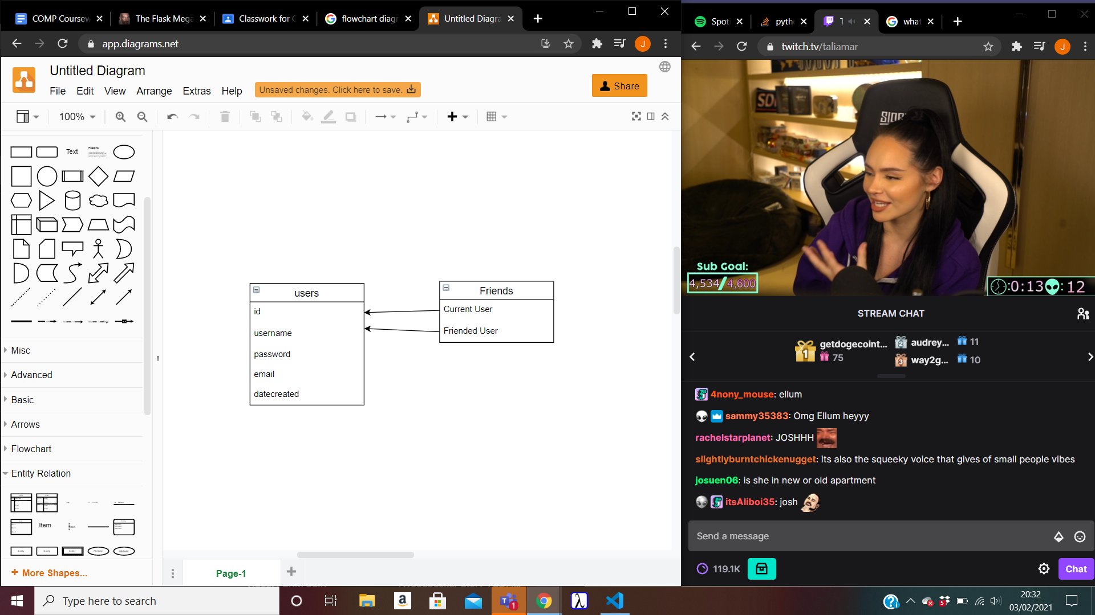

I will be using for a friending system

The foreign keys are both pointing to the user table, since we are linking users to users. Each record in this table represents one link between the current user and the friend. This one allows our database to answer all the questions about current user and friend user that we will need.

**Technical Solution**